MySQL and PHP from Puppet Master to Puppet Slave
- We will use predefined modules available at forge.puppet.com
Step 1: In Puppet Master install MySQL and PHP modules.
[ec2-user@ip-172-31-3-227 ~]$ sudo puppet module install puppetlabs-mysql
Notice: Preparing to install into /etc/puppet/modules ...
Notice: Downloading from https://forgeapi.puppetlabs.com ...
Notice: Installing -- do not interrupt ...
/etc/puppet/modules
└─┬ puppetlabs-mysql (v5.3.0)
├── puppet-staging (v3.1.0)
├── puppetlabs-stdlib (v4.24.0)
└── puppetlabs-translate (v1.1.0)
[ec2-user@ip-172-31-3-227 ~]$

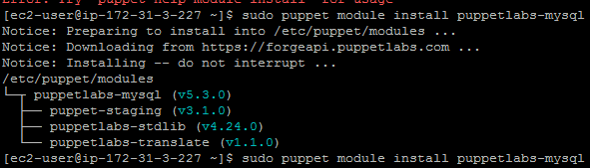

Install php
puppet module install mayflower-php
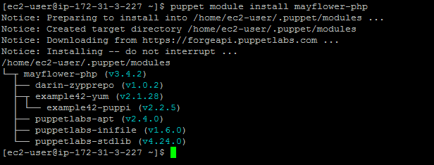
Step 2: In Puppet Manifests include MySQL server and PHP.
Execute this: vi /etc/puppet/manifests/site.pp

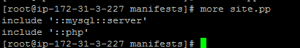

puppet module install puppetlabs-java
puppet module install puppetlabs-tomcat
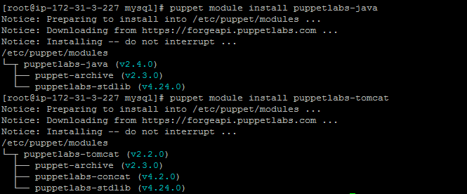

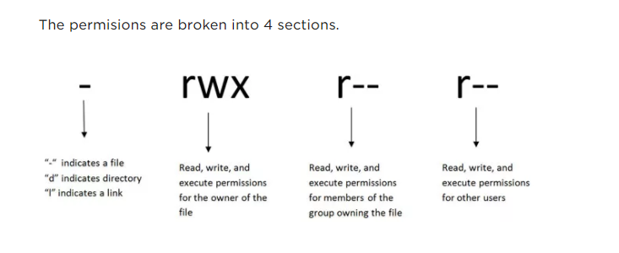

Permission in numeric mode
What are the numbers?
0 = No Permission
1 = Execute
2 = Write
4 = Read

